INORGANIC PARTICULATE DETACHMENT INTO MEDICAL AIR OUTLETS OF HOSPITALS AND DENTAL CLINICS

Prashant Nagathan, Robert Baier, Robert Forsberg, Anne Meyer,
University at Buffalo, Buffalo, NY, USA, baier@buffalo.edu

Introduction

In the course of examining the microbiological quality of Medical Air USP exiting into patients’ potential breathing spaces in 5 hospitals, as well as compressed gas sources delivering air to dental clinic handpieces and into research laboratories, an unexpected finding was significant amounts of respirable inorganic matter dominated by such elements as copper, tin, potassium, chlorine, bromine, iron, zinc, sulfur, sodium and silicon. The sampling technique employed direct air impaction onto pre-cleaned and “baselined” germanium prisms used directly for internal reflection infrared spectroscopy and then scanning electron microscopy and energy-dispersive X-ray analysis, with no need for sample coating, transfer, or other possible compromise. In the cases of dental clinic facilities, the infrared inspections revealed oily deposits and some possible corrosion-inhibitor organics as well as the copper-zinc-tin-potassium-chlorine particles. The likely source for the inorganic particulate debris, as judged from the elemental makeup and comparisons with the ingredients of solder/welding fluxes, is internal piping joint debris in the predominantly copper-based plumbing conduits through which the finally filtered, compressed Medical Air is delivered to the patient or clinical room. Recognizing that solder/weld fluxes work intrinsically by corrosive processes to establish clean surfaces for adhesion, the concern arises that continuing corrosion within the conduits might produce particulate matter that can be entrained in the exiting high pressure air stream. A known similar event is continuing “tin whisker” formation in microelectronics.

Experimental

For sampling the compressed medical air to detect microorganisms, two sampling devices were used. One was a Veltek- SMA sampler designed for sampling compressed air/gas at maximum pressure of 100 psi. The second was a modified Andersen sampler, which is a single-stage Andersen sampler converted to sample compressed air at pressure of 50-55 psi. Four biological growth media, Blood Agar (BA), Rose Bengal agar (RBA), R2A and Tryptic Soy Agar (TSA) were used for sampling:
- Blood Agar was incubated at 35º C for 4 days to detect human-associated bacteria.
- Rose Bengal Agar was incubated at room temperature, 23 +/- 3 º C for 7 days to detect fungi.
- R2A was incubated at room temperature, 23 +/- 3 º C for 4 days to detect environment-associated bacteria.
- Tryptic Soy Agar was incubated at 56º C for 4 days to detect thermophilic bacteria.
The medical air was sampled at two time periods, 1 minute and 3 minutes, at constant flow rates of 1 cubic foot per minute (CFM). At each hospital, 6 sets of duplicate samples (except for TSA) were taken from the compressed medical air USP outlet as described in the following tables.

For the Anderson sampler:
1 minute | 3 minute
2 RBA | 2 RBA
2 R2A | 2 R2A
2 BA | 2 BA
1 TSA | 1 TSA

For the SMA sampler:
1 minute | 3 minute
2 RBA | 2 RBA
2 R2A | 2 R2A
2 BA | 2 BA
1 TSA | 1 TSA

Background air samples were taken inside each hospital, where the medical air samples were taken, and also outside the hospitals on TSA (kept at 35ºC for 4 days). The head of the SMA sampler, hose, adaptor, connectors and stainless steel pipe hose used for modification of the Andersen sampler were autoclaved at 121ºC for 15 minutes. The pressure regulator was disinfected with 95% ethanol before sampling at each hospital. Before taking medical air samples on any media, the Andersen sampler plate, the atrium base and edge of the SMA Head were wiped with ethanol pads. After taking the samples, the media dishes were sealed with wax film and were kept in different incubators at the temperatures noted above.

For the analysis of particulate debris, the medical air was impacted directly onto germanium prisms kept in rigid prism holders for 1 hour. The flow rate of the medical air coming out from the hose directed to the air impactor was approximately 1m³/min. In order to make sure that the particles were coming from the medical air and not from the hose connection, the medical air also was directly impacted on the germanium prism, clamped directly in front of the wall outlet of the medical air by using special attachments (Figure 1). Analysis confirmed that the same particles were seen on both sample types, the germanium prisms were held directly in front of the wall outlets and others kept in an impactor holder. Prior to medical air sampling, each germanium prism was cleaned with detergent (Sparkleen, Fisher Scientific) and was glow-discharge cleaned for 2 minutes using a gas-plasma unit (Harrick Scientific Corporation, Ossining, NY). The baseline MAIR-IR spectrum was recorded for each cleaned prism using an infrared spectrophotometer (Model 1420 ratio recording infrared spectrophotometer, Perkin-Elmer Corporation, Norwalk, CT) with special MAIR-IR mirror optics. At the end of air impaction, the same prism was then analyzed again by MAIR-IR spectroscopy, SEM and EDX for any collected organics, oil droplets and other particulate matter.

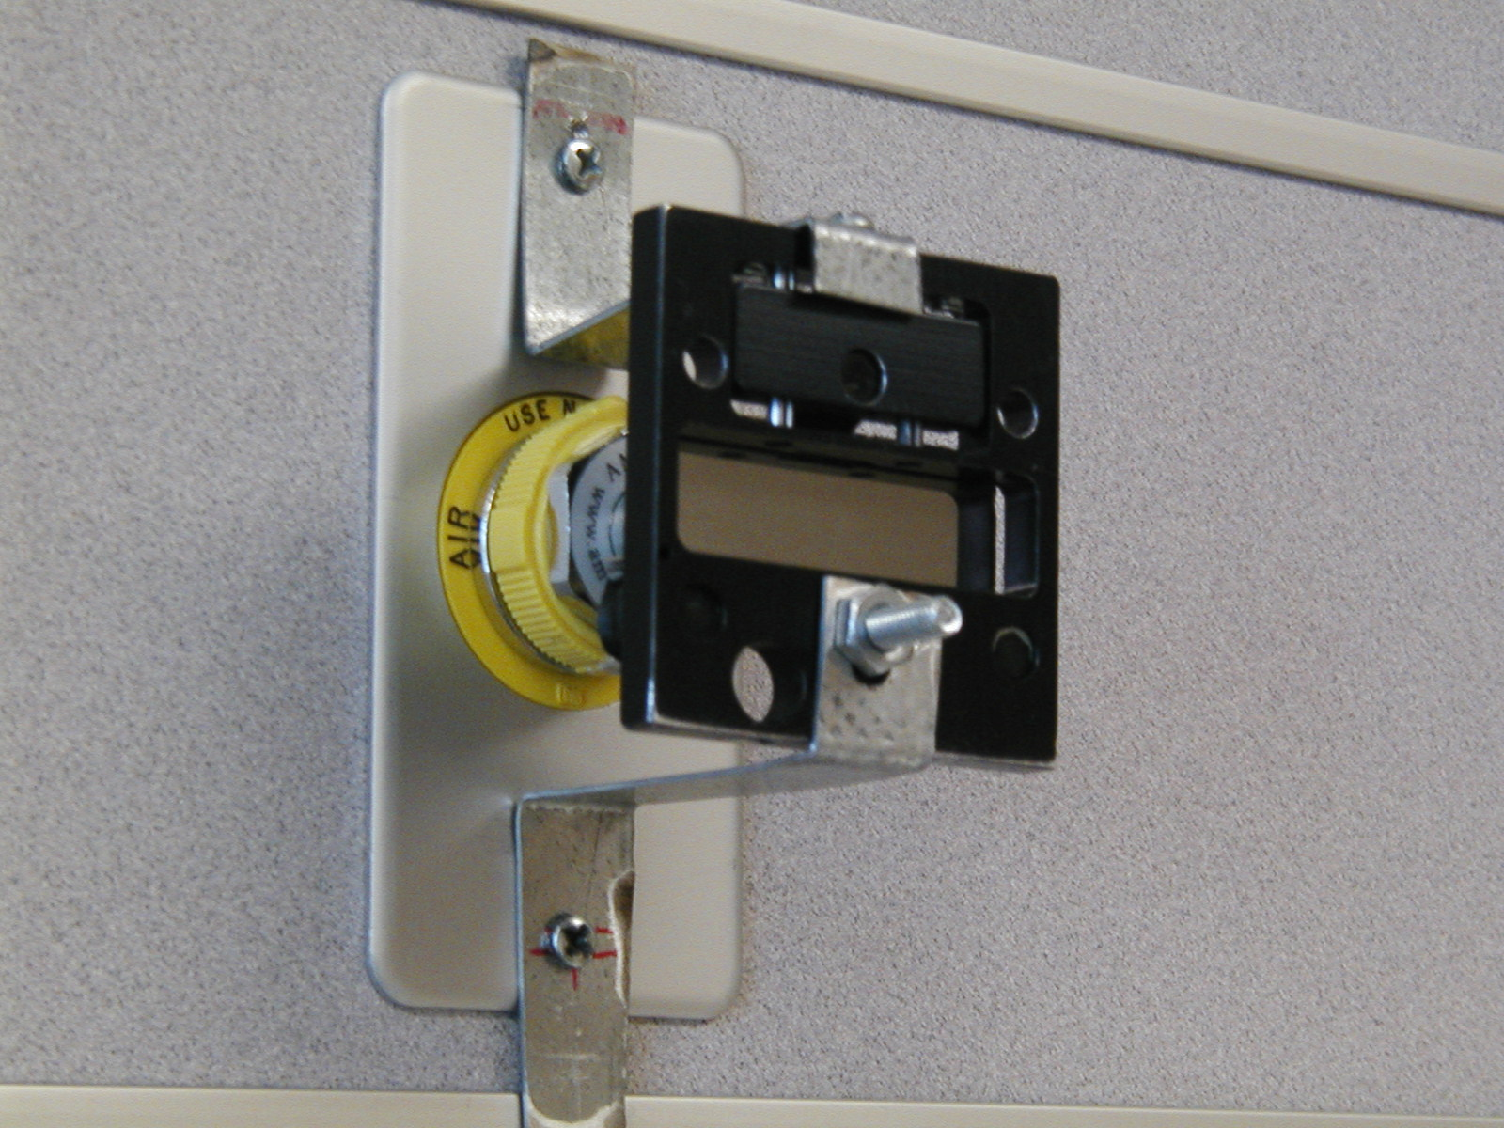
Figure 1. Germanium internal refelection prism clamped directly in front of Medical Air outlet.

Results and Discussion

No medical air samples from either of the two microbial samplers showed microbial growth on any of the media exposed at five hospitals in Western New York.
Infrared spectra for the impacted particulates showed no spurious organic chemical absorption bands for Hospitals 1, 2 and 3. The Hospital 4 sample showed some presumptive silicone contamination, and the sample for hospital 5, had additional hydrocarbon bands between 2800 cm⁻¹ to 3000 cm⁻¹, indicative of the possible presence of fine oil droplets in the medical air.

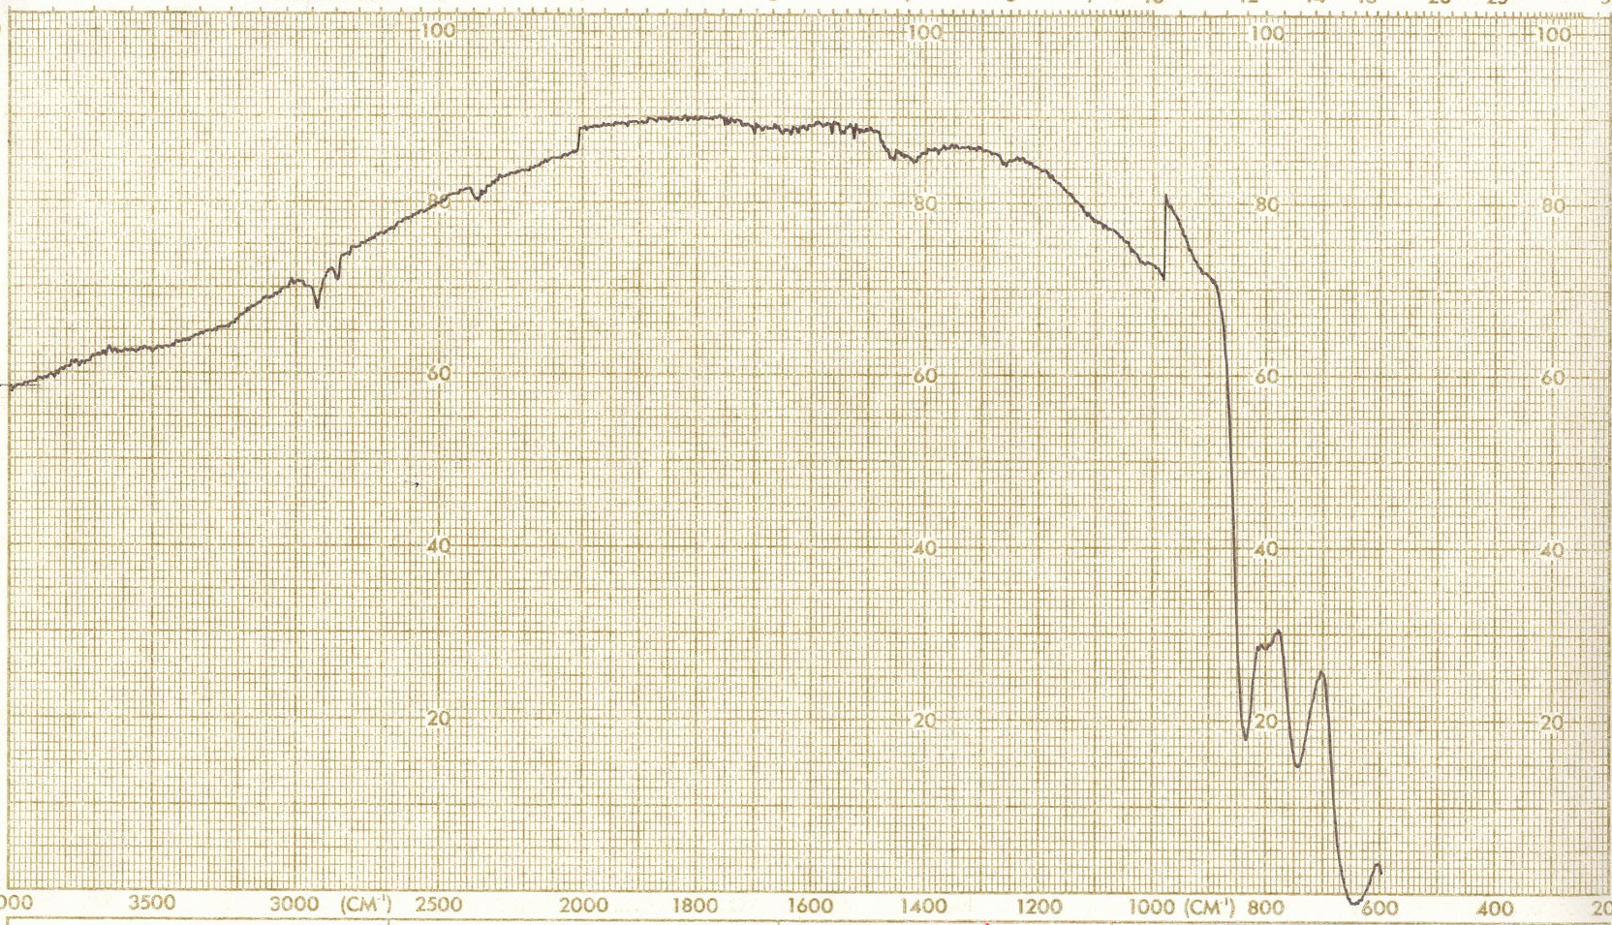
Figure 2. MAIR-IR spectrum of medical air from hospital 5 impacted on germanium prism for 60 minutes at the flow rate of 1m³/min.

In Figure 2, hydrocarbon bands between 3000cm⁻¹ and 2800 cm⁻¹ and additional bands near 1450 cm⁻¹ 1260 cm⁻¹, suggest fine oil mist contamination of the Medical Air stream.
Scanning Electron Microscopy (SEM) analysis showed presence of particles of size ranges 0.1 to 100 micrometers in the impacted medical air samples from every hospital source. Hospital 5 had more particles compared to other hospitals; the concentrations of particles in the medical air were not analyzed in the current study. Energy Dispersive X-ray (EDX) analysis showed that these particles contained K, Ca, Zn, Al, Mg, Cl, Br, Si, Fe, Cu, Sn, Li. Consultation with a welding expert provided references indicating these particles probably derived from soldering and fluxes during the plumbing of the copper pipes (copper piping is used in these five hospitals to transport the medical air from compressors to the outlets).

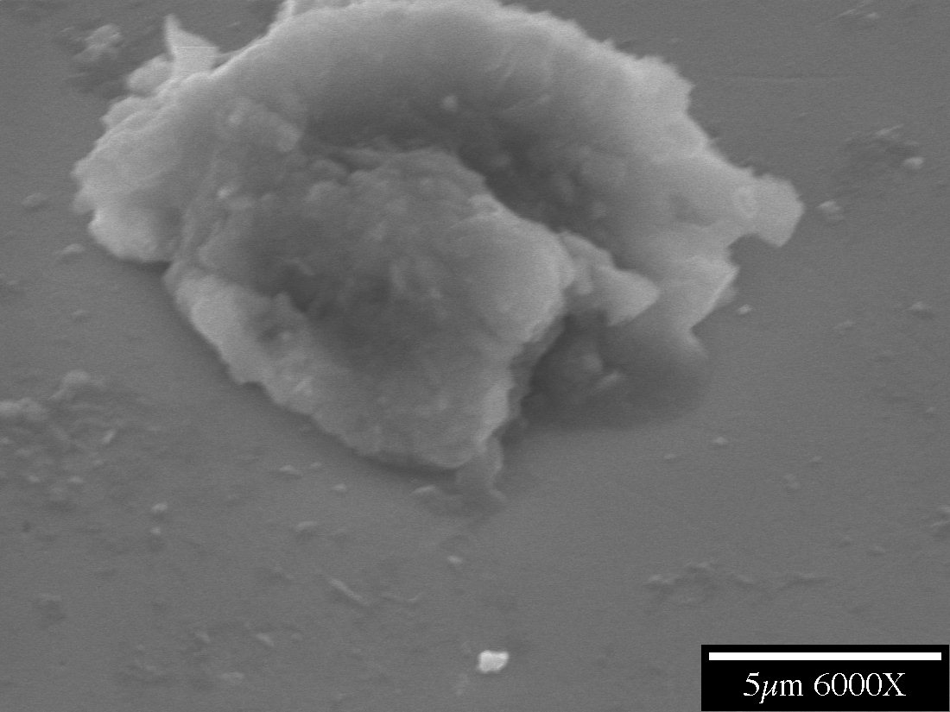
Figure 3. SEM picture of a particle from Medical Air.

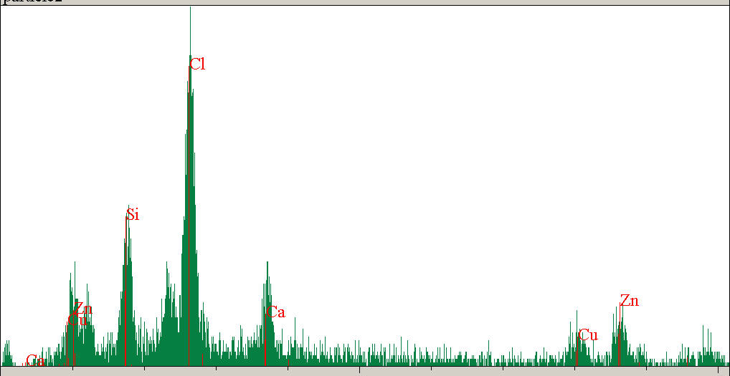 Figure 4. EDX analysis of the above particle

Discussion and Conclusions

The probable inorganic parrticulate contamination of compressed medical air used in hospitals has not received prior attention. Bjerring and Oberg (1986) investigated the bacterial contamination of medical air in one hospital of Denmark. The hospital compressor was not oil free and the compressed air was not dried completely (Hay, 2000) as it is done now by refrigerants. The oil and water aerosol was the source for bacterial growth in the pipeline of medical air in the hospital. Nakata et al (2002) investigated the gaseous pollution of medical air at University Hospital in Tokyo. They noticed a rise of SO2, NO and NO2 above the standard level determined by the Environment Agency of the Japanese government, in the medical air, during the peak rush hours of the day, attributed to the chronic traffic congestion in Tokyo.

In the five hospitals investigated in this study, the medical air analyzed had already been tested for chemical composition in the air by consulting laboratories hired by the hospitals twice a year, and found to be within specification. With improvements in compressor manufacturing, by using oil free compressors and drying the air by use of refrigerants, bacterial contamination of medical air by viable microbes has apparently been reduced to zero.

This investigation has shown there are previously unnoticed particles in the medical air, probably generated from the fluxes during the soldering/welding operations in initial construction or system upgrades. Air having particles with high concentrations of elements like copper and tin should be investigated further. Based on discussion with hospital personnel, for future medical air sampling, media which favor Legionella growth should also be used along with other media. The relative efficiencies of the SMA sampler and modified Andersen sampler could not be compared in the current study because there were no culturable organisms in the air tested.

Acknowledgments

Richard Hall, DDS, MD and Corstiaan Brass, MD kindly arranged access to the medical and dental facilities sampled. Thank you to Tamara Brown of Praxair, Inc., Tonawanda, NY, for the kind loan of important high pressure gas sampling equipment, supply of bacterial culture media, and internship financial support to P.N. Mr. Leonard Borzynski of the University at Buffalo kindly loaned the Andersen sampling equipment. Special appreciation is noted for the facilities and operating personnel of Western New York regional hospitals and dental clinics, and to Ms. Susan Scamurra of the Buffalo Technology Transfer Center, for arranging access to the medical air outlets, and to Paul Bachkowski of Matrx Medicals for supplying outlet connectors.

References

Bjerring P and Oberg B, 1986 Bacterial contamination of compressed air for medical use. Anaesthesia 41:148-150

Hay H, 2000 Contamination of piped medical gas supply with water. European Journal of Anaesthesiology 17(8): 512-514

Nakata Y, Kawasaki Y, Matsukawa K, Goto T, Miimi Y and Morita S, 2002 Pollution of the medical air at a university hospital in the metropolitan Tokyo area. Journal of Clinical Anesthesia 14: 193-195.

