FINE PARTICLE PERSISTENCE IN BALLAST WATER SEDIMENTS AND BALLAST TANK BIOFILMS

Robert Forsberg, Robert Baier, and Anne Meyer, University at Buffalo, Buffalo, NY, USA, baier@buffalo.edu, Martina Doblin, Old Dominion University, Norfolk, VA, USA, mdoblin@odu.edu, and Matthew Strom, D’Youville College, Buffalo, NY, USA, zero200@aol.com

Introduction

There is a worldwide concern about the distribution of potentially “bioinvasive” species in the ballast waters carried/discharged/exchanged by commercial vessels moving from port to port [1]. Even in ships declared to be NOBOB (No Ballast On Board) upon entering new territorial waters, there are usually at least 50 metric tonnes of sediments and remaining ballast water in the ships’ holds, easily re-suspended when re-ballasting for hydrodynamic stability of ships in transit to the next port. This experiment began with the unexpected discovery of nominally 1-micrometer green-fluorescent beads in ballast water biofilms formed on clean test substrata within “control” and flow-exchanged ballast tanks of a vessel transiting from Holland to Canada, in 2002. It was later determined that these marker particles had been deliberately added to the tank sediments at the beginning of the voyage, to help judge the efficiency of the at-sea, flow-through ballast water exchange procedure. New Ballast Organic Biofilm (BOB) units containing clean test coupons [2] were suspended above the bottoms of the two originally particle-seeded tanks, and allowed to spontaneously acquire deposited biofilms with entrapped fine sediments over the next year of commercial voyages, exposing the ballast tank volumes to over 80 flow-through volume exchanges with deep-ocean seawater exceeding 10,000 cubic meters for each occasion. Harvesting of the BOBs in May 2004, followed by fluorescence microscopic inspection of the acquired biofilms and associated fine sediments, revealed abundant fluorescent beads retained in spite of the nearly million-fold dilution expected from the flow-through ballast water exchanges. Fine sediment particles in ballast tanks remain persistently available to re-seed ballast tank biofilms even after numerous ballast water exchanges.

Experimental

The experiment began on 02July2002, hosted aboard the motor bulk carrier BERGE NORD (Bergesen d.y. ASA, Table 1) embarking on its 65th voyage (leg 130) from Rotterdam, the Netherlands to Sept Isles, Canada, hosted by Captain Ashok K. Pandey.

Table 1. Berge Nord Specifications
Category: Motor Bulk Carrier
Length and Gross Tonnage: 305m; 107,512 MT
Route: Rotterdam, The Netherlands
to Sept Iles, Canada

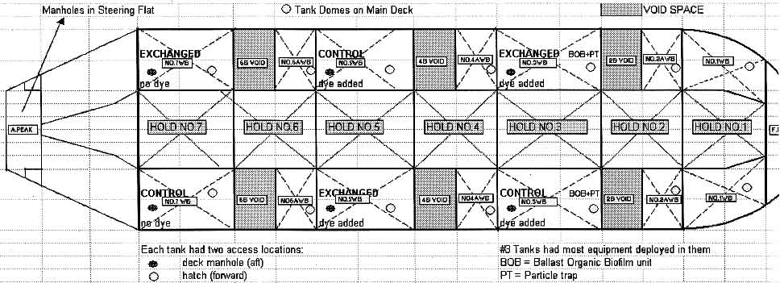

Figure 1. Layout of the Ballast Tanks aboard BERGE NORD

While the ship was berthed in Rotterdam, nominally 1-micrometer diameter fluorescent spheres were added equally into the 11,665 cubic meter volumes of ballast tanks #3Port and #3Starbord (see Figure 1) to achieve suspension concentrations in the range of 15-150 beads per liter depending on dispersion efficiency. Ballast water exchange was conducted on Berge Nord once the vessel was 200 nautical miles southwest of the British Isles, by gravitationally dropping the Holland coastal water in the designated exchange tanks to 20% of initial volume while deep oceanic water was simultaneously pumped into the bottoms of the tanks with excess overflowing out of the tanks’ deck hatches. Each test ballast tank was exchanged with three tank volumes of ocean water, in accordance with the International Maritime Organization (IMO) guidelines for the flow-through method, using two pumps operating for 24 hours.
Exchange efficiency measured with a non-toxic fluorescent dye showed that 95% of the coastal water in tank #3P was replaced. The control tanks were similarly exchanged just before ship arrival at Sept Isle, allowing for an on-board scientific team to collect water from un-exchanged “control” tanks as a reference against the exchanged “treatment tanks” before and after they underwent exchange, as well as to implement other short-term experiments on “Effects of Open-Ocean Exchange on Microbial Communities in Ships’ Ballast Tanks” [3]. There were two BOBs, one in each of the tanks #3P and 3S, with 96 test coupons of reference grade polystyrene(PS), and of silicone-coated PS, placed in each, half facing up and half facing down to allow a judgment about suspension delivery versus gravitational settling of acquired deposits.
After it was discovered by fluorescence microscopic inspection of the test coupons that the nominally one-micrometer fluorescent marker beads were present within all the biofilms and sedimentary deposits on all the specimens, arrangements were made to re-install the two BOBs with clean coupons in their original settings within Berge Nord ballast tanks #3P and #3S, on voyages hosted by both Captain Pandey and Captain Ainsley A. Athaide on repetitive transAtlantic 2-week cycles through May 18, 2004. The BOBs with all PS coupons were exposed to the additional ballast water volumes that cyclically re-suspended sediments containing only the fluorescent marker beads remaining from the July 2, 2002 first addition, and retained through an estimated million-fold dilution via the rigorous IMO- recommended flow-through technique for ships in international commerce.
Upon return of the BOBs to the laboratory, fluorescence microscopy was used to enumerate the beads resident in the acquired bacterial biofilms on the coupons, all the particulates having arrived from the suspended or re-suspended materials in the ballast water volumes. Samples of the ballast water tank bottom sediments were also inspected.

Results and Discussion

Figure 2 shows a typical fluorescence photomicrograph of the beads retained within a spontaneously formed biofilm. In this case, the biofilm was on a coupon placed within a BOB carrier experiencing over 80 ballast water exchanges from an intial concentration of fewer than 100 beads per liter.

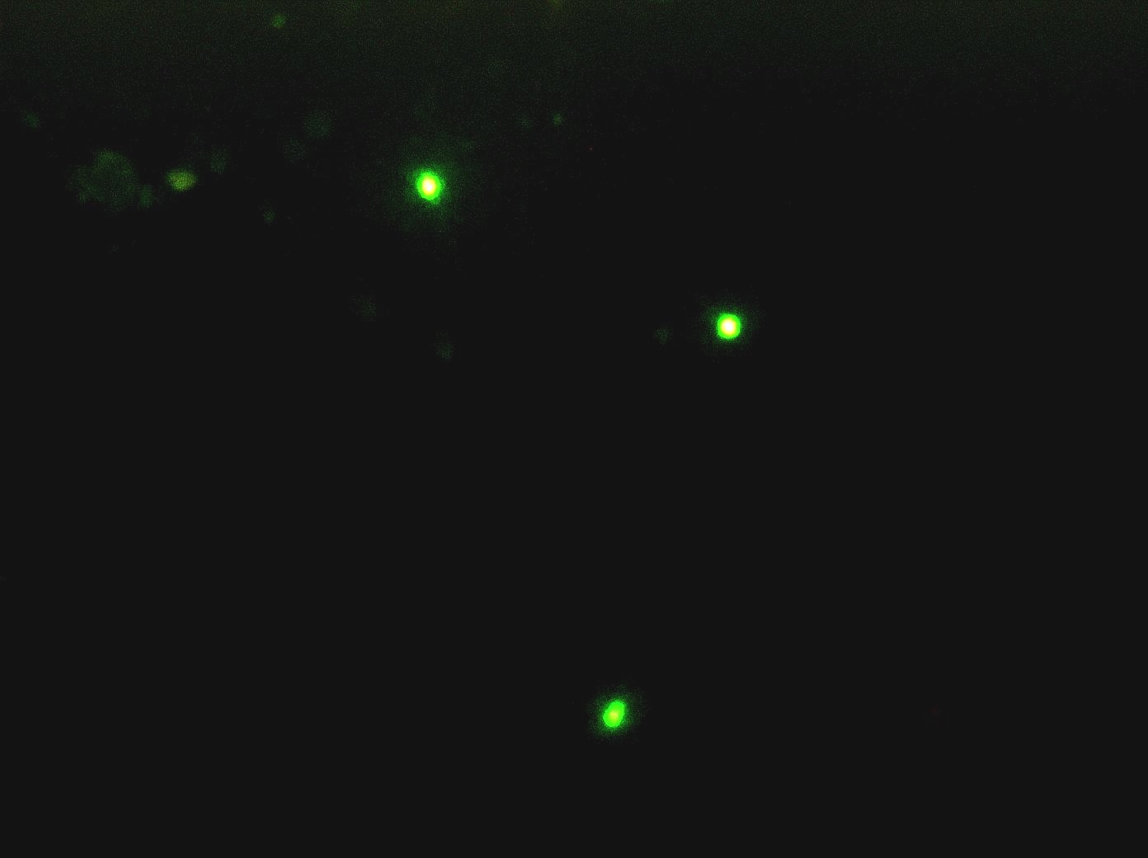

Figure 2. Fluorescence photomicrograph of fluorescent beads (1 micrometer diameter) in biofilm.

Typical counts obtained by full area inspections of each of the 1”x3” PS coupons for all the specimens are clear from this illustrative data set:

#42 Starboard facing up = 193 beads
#42 Starboard facing down = 192 beads
#42 Port facing up = 86 beads
#42 Port facing down = 216 beads

Figure 3 shows a view from a companion coupon, also containing numerous PS beads (lower magnification than Figure 2) but revealing a mussel veliger attached within that biofilm. The veliger is about 100 micrometers across, and representative of the form of the “zebra mussel” Great Lakes invaders that probably first gained entry to the North American inland seas by exactly this transport mechanism.

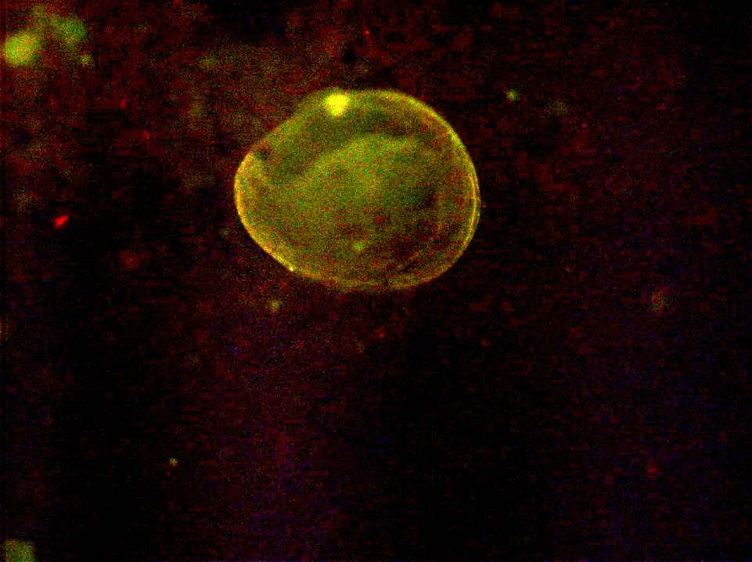

Figure 3. Fluorescence photomicrograph of ballast tank biofilm. Mussel veliger (approx. 100 micrometers diameter) is autofluorescent.

Among the most interesting and important considerations emerging from this non-obvious discovery of the extreme inefficiency of small particle removal from ballast water sediments is an increased concern for the global transport of aquatic invasive species within some dinoflagellate and bacterial families that propagate via cysts and spores. Dinoflagellate cysts and bacterial spores are of similar densities and sizes to the marker beads studied here, and these propagules can be germinated into viable organisms from biofilms that entrain them, as well as from sediments.

Our objective in proposed future research is to further engage with our Berge Nord colleagues to implement an experiment consisting of alternate tank sampling and cleaning, with simultaneous and sometimes iterative deployment of differently colored fluorescent microspheres as the ship continues to move between the Netherlands and Canada on its dedicated route. The originally seeded and new microspheres will serve as cyst and spore surrogates and allow us to better understand the sedimentation and re-suspension phenomena as well as susceptibility to removal by more aggressive tank cleaning techniques, of potentially bioinvasive species that become resident in ships’ ballast tanks by inadvertent or deliberate introductions.

Conclusion

The demonstrated inefficiency of microbial-sized particle removal from ballast water tanks by multiple flow-through exchanges of open ocean water should prompt a re-evaluation of this method as the recommended approach to minimize the risk of port-to-port transport of potentially bioinvasive organisms.

Acknowledgments

The authors thank Bergesen D.Y. for allowing this research to be conducted on board their vessel. The shipboard work was supported by the Great Lakes Protection Fund, co-managed by the Cooperative Institute of Limnology and Ecosystems Research and the NOAA Great Lakes Environmental Research Laboratory, and sponsored under cooperative agreement NA17RJ1225 from NOAA’s office of Oceanic and Atmospheric Research. Analyses of the biofilms at University at Buffalo were supported by the Industry/University Center for Biosurfaces.

References

1. L.A. Drake, A.E. Meyer, R.L. Forsberg, R.E. Baier, M.A. Doblin, S. Heinemann, W.P. Johnson, M. Koch, P.A. Rublee, and F.C. Dobbs, Biological Invasions, 2005, in press.

2. A.E. Meyer, R. Baier, N. Hulsmann, B. Galil, D. Friedmann, and R. Forsberg, Abstracts Book, American Society of Limnology and Oceanography, Aquatic Sciences Meeting, 2000, abstract #SS08-p22.

3. M.A. Doblin, F.C. Dobbs, L.A. Drake, M. Bednarski, K. Coyne, S. Heinemann, G. DiTullio, L.G. Kampschmidt, T. Mullady, K. Murphy, and G. Ruiz, Proceedings, Third International Conference on Marine Bioinvasion, 2003.

